Blockchain Based Certificate Validation

In this project to secure academic certificate and for accurate management and to avoid forge certificate we are converting all certificates into digital signatures and this digital signatures will be stored in Blockchain server as this Blockchain server support tamper proof data storage and nobody can hack or alter its data and if by an chance if its data alter then verification get failed at next block storage and user may get intimation about data alter.

In Blockchain technology same transaction data stored at multiple server with hash code verification and if data alter at one server then it will detected from other server as for same data hash code will get different. For example in Blockchain technology data will be stored at multiple servers and if malicious users alter data at one server then its hash code will get changed in one server and other servers left unchanged and this changed hash code will be detected at verification time and future malicious user changes can be prevented.

In Blockchain each data will be stored by verifying old hash codes and if old hash codes remain unchanged then data will be consider as original and unchanged and then new transaction data will be appended to Blockchain as new block. For each new data storage all blocks hash code will be verified.

In this project we have designed following modules

1. Save Certificate with Digital Signature: Using this module admin user can upload student details and student academic certificate and then application convert certificate into digital signature and then signature and other student details will be saved in Blockchain database.
2. Verify Certificate: In this module verifier or companies or admin will take certificate from student and then upload to application and then application will convert certificate into digital signature and this digital signature will get checked/verified at Blockchain database and if matched found then Blockchain will retrieve all student details and display to verifier and if match not found then this certificate will be consider as fake or forge.

To design Blockchain database and storage we have written following code shown in screen shots and in below screen shots read red colour comments to understand Blockchain code

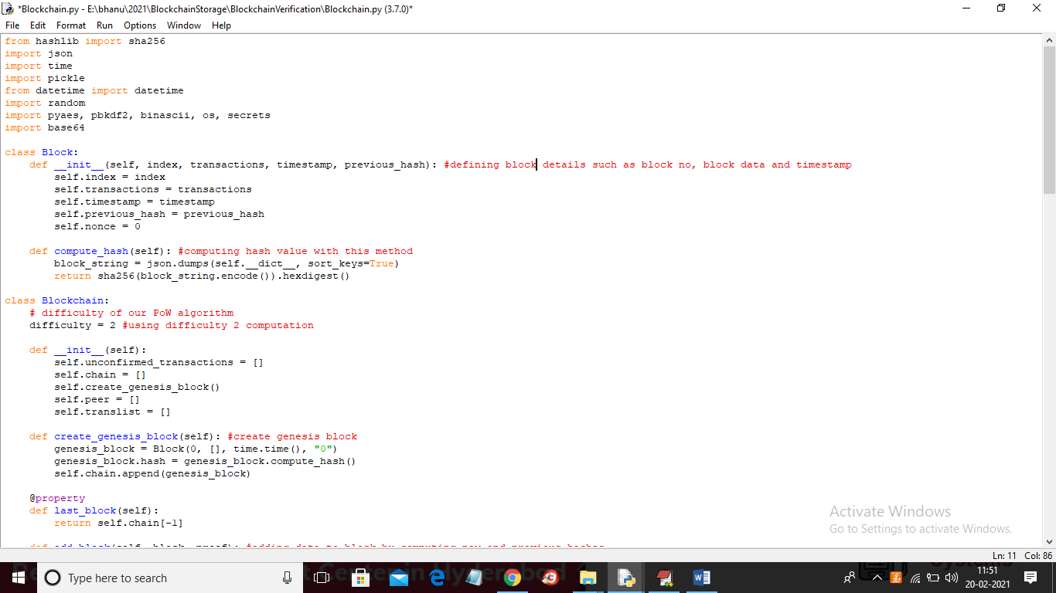

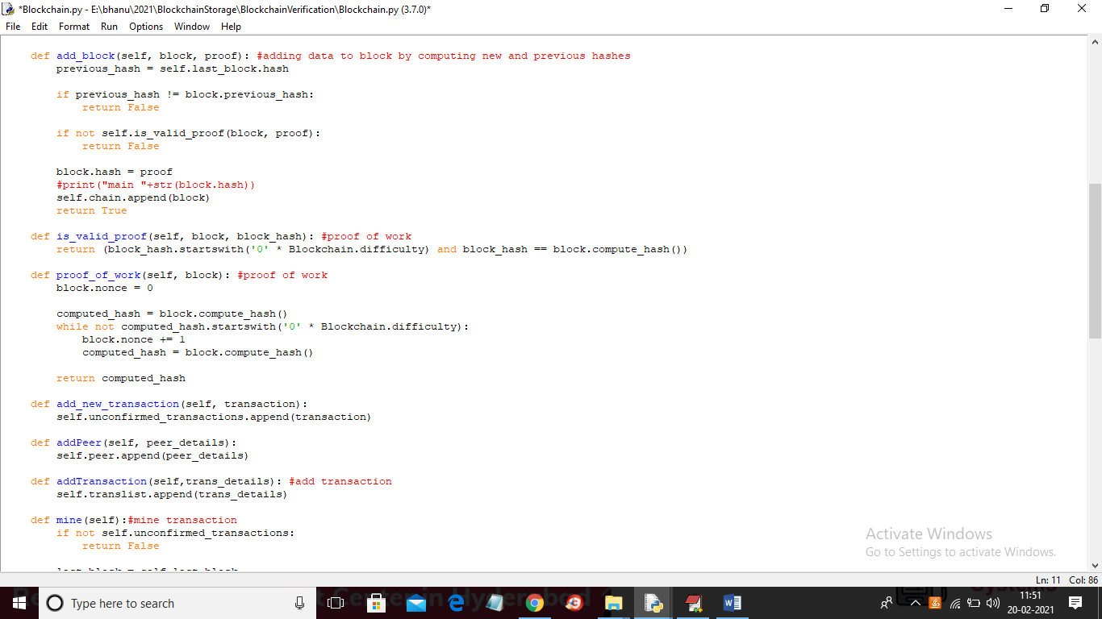

To implement this project we have taken some certificates and this certificates stored inside ‘certificate_templates’ and you can use those or you own certificates to upload to Blockchain and below is the certificate screen shots

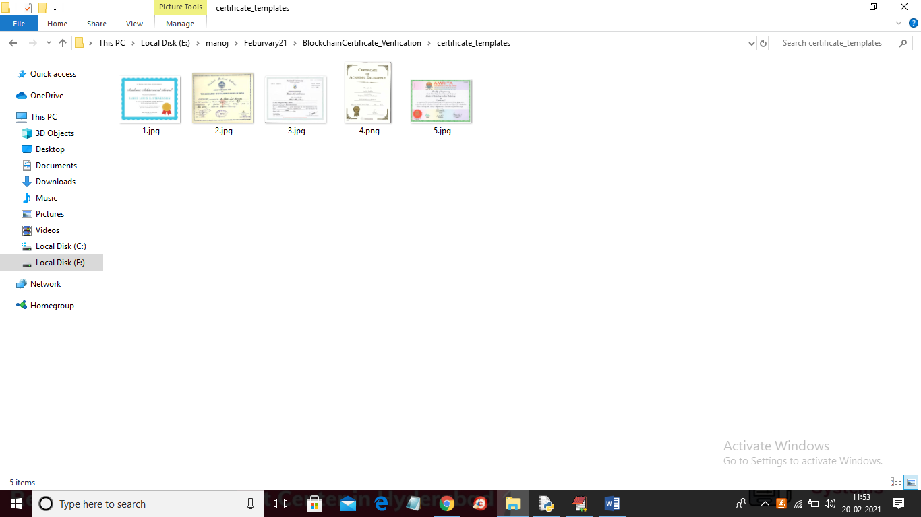

SCREEN SHOTS

To run code double click on ‘run.bat’ file to get below screen

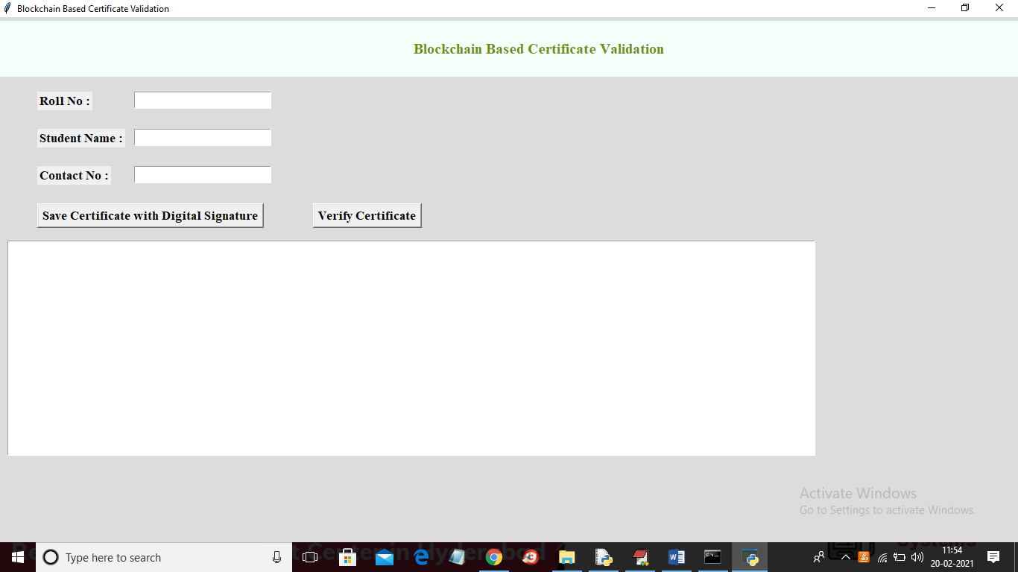

In above screen enter student details and then click on ‘Save Certificate with Digital Signature’ button to convert certificate into digital signature and then saved in Blockchain

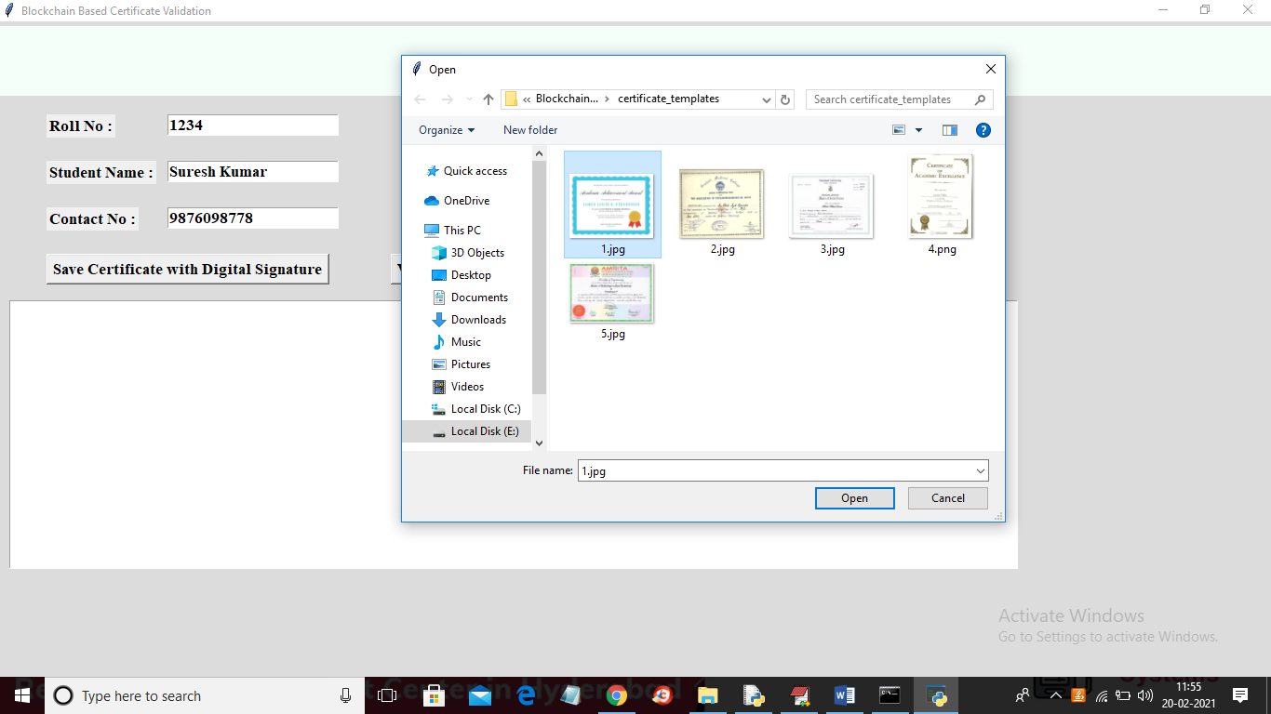

In above screen entered some student details and then click on ‘Save Certificate with Digital Signature’ button and then selecting and uploading ‘1.jpg’ file and then click on ‘Open’ button to get below screen

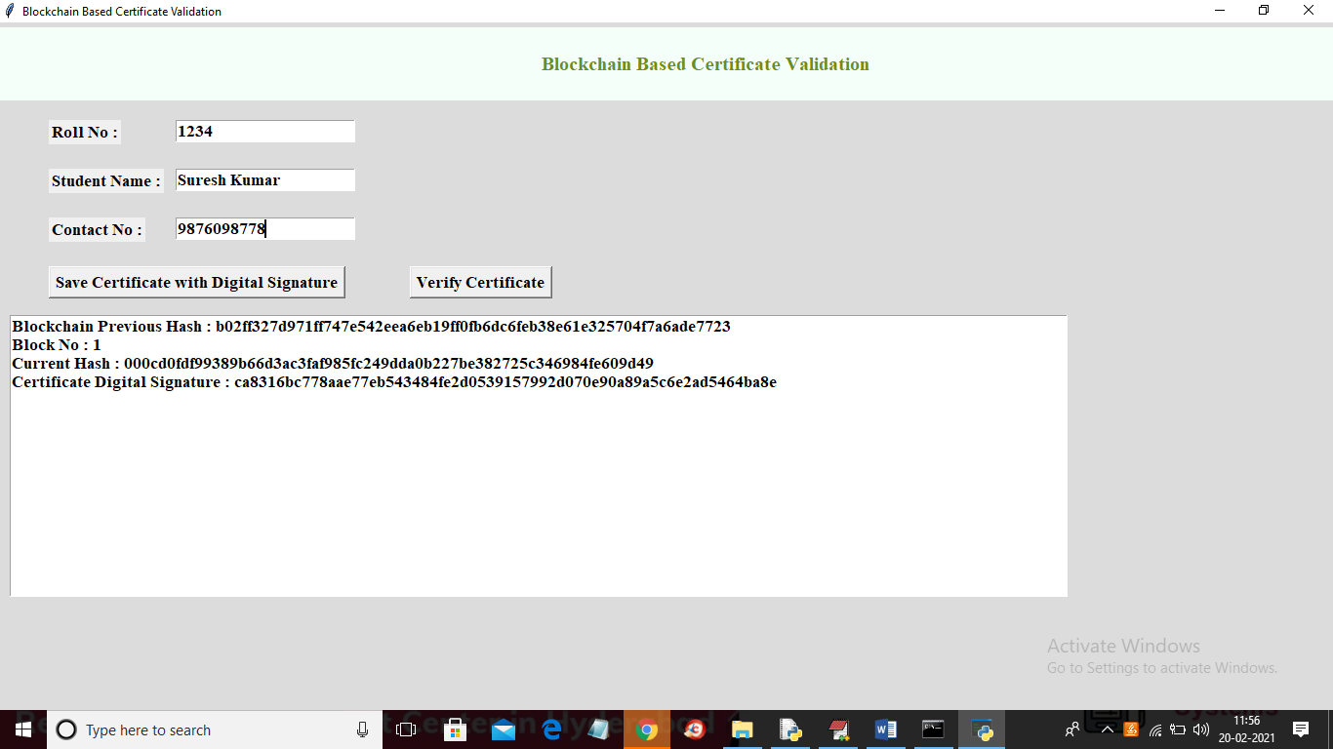

In above screen we can see Blockchain generated previous hash with block no 1 and its current hash and then keep on generating new blocks with each certificate upload and while running you can see that previous hash of new record will get matched with current hash of old record and this matched hash code proof that Blockchain verify old and new hash code before storing new block to confirm data is not altered. So above details stored at Blockchain and now verifier can click on ‘Verify Certificate’ button and upload same or other images to get below result

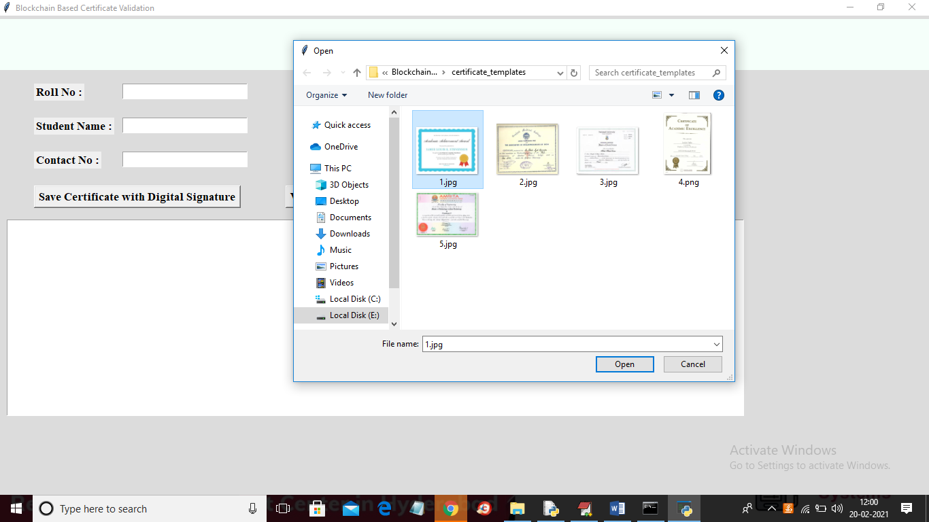

In above screen selecting and uploading ‘1.jpg’ file and then click on ‘Open’ button to get below result

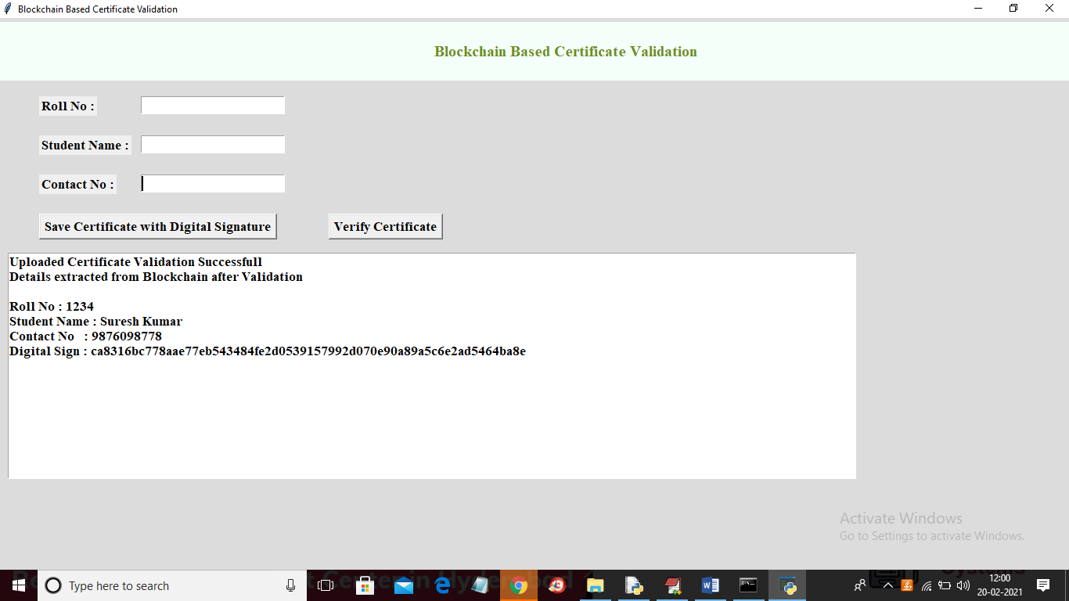

In above screen we uploaded same and correct image so application matched digital signature and then retrieve details from Blockchain and now try with some other image

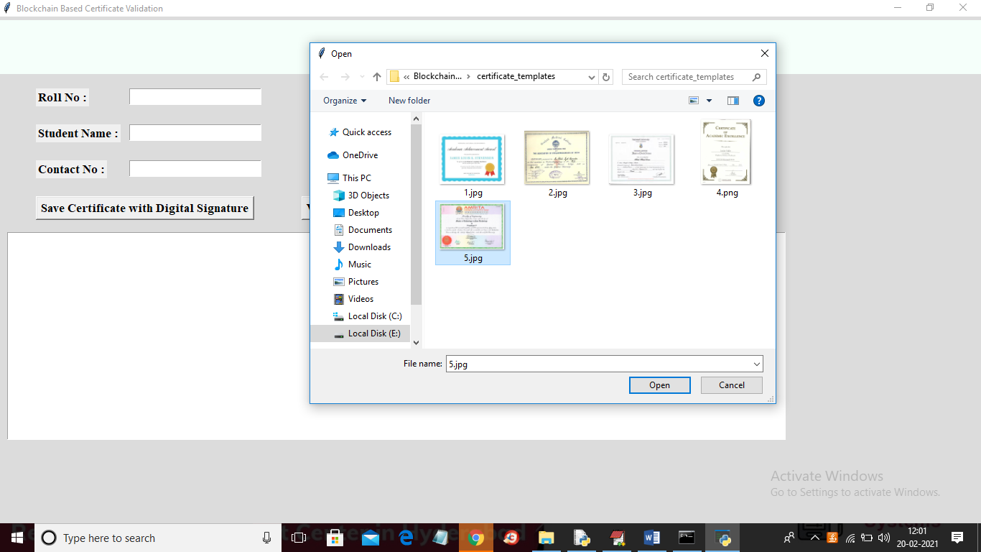

In above screen selecting and uploading ‘5.jpg’ file and then click on ‘Open’ button to get below result

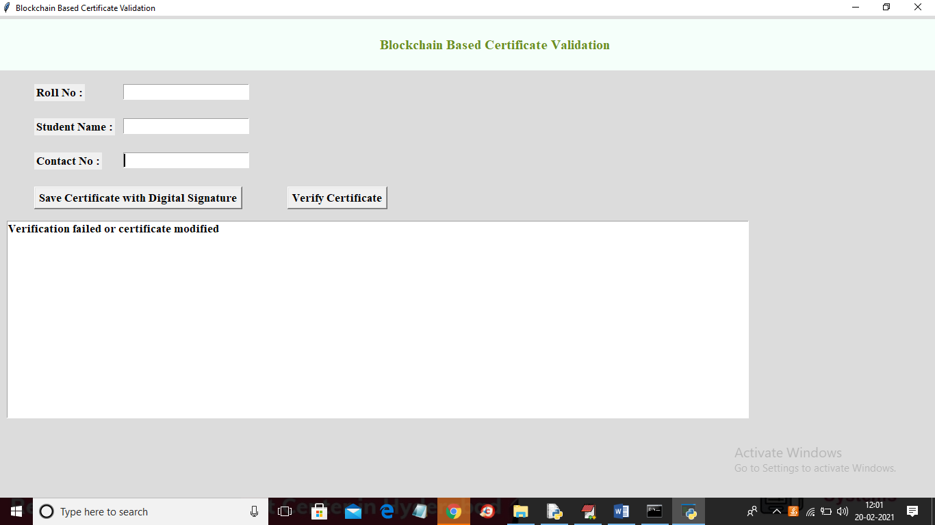

In above screen verification got failed as uploaded certificate not matched with stored certificates in Blockchain.

Similarly you can upload any other certificate and convert them to digital signature